Fox Valley Data Exchange
Data Structure and Framework Action and Advisory Team
Data Source Document
Contents
Data Source/Topic 1
Use Case 2
Input File Dimensions 2
Input Data File 2
Download Instructions 2
Discipline Actions_certified_Download File layout 2
File Lookups 3
School Address File 4
Stratifications File 4
Places File 5
Output Files for Metopio 5
Statewide Layer 7
Tri-County Layer 8
County Layer 8
Zip Code Layer 9
City or town Layer 10
Validation Method 10
Code to format the files 12
Authenticity 12
Comments 12

Data Source/Topic

Identifier | FVDEX-PP-10
Data Source Name | WISEdata
Data Source Link if any | WISEdash Public Portal - Department of Public Instruction  WISEdash Data Files by Topic | Wisconsin Department of Public Instruction  Download Type = ‘Forward’  Input: the files that are named as forward_certified_2023-24.zip  including 2023 forward
Topic Name or other specifics within data source | Public School Forward Exam Prof (3rd Grade Reading) Count  Public School Forward Exam Prof (3rd Grade Reading) %  (proficient at grade level)  This specification includes two topics.
Vital Condition | Lifelong Learning
Requested by (name) | Sarahjean Schluechtermann
Update frequency | Yearly in September
Cost to obtain | free
Contact to obtain | none
Recorded by (Data Dingo conducting interview) | Susan Conzelman
Technical Solution | Shaaz Anaam

Use Case
This metric provides direction on readiness

Input File Dimensions

Input Data File

Download Instructions
There is one file for each year which can be found in this link:
WISEdash Data Files by Topic | Wisconsin Department of Public Instruction
Filter Download Type dropdown to “Forward”
The files that begin with “forward_actions_certified” followed by the school year range.zip are the ones to download. Click on the file name and open the file from your browser pop-up:

Forward_certified_Download File layout
Columns used are in bold:
Field No | Field Name | Field Datatype | Length | Field Description
1 | SCHOOL_YEAR | Text | 7 | School year of enrollment
2 | AGENCY_TYPE | Text | 50 | School/district type
3 | CESA | Text | 10 | Cooperative Educational Service Agency
4 | COUNTY | Text | 50 | County of main district office
5 | DISTRICT_CODE | Text | 10 | District code - Unique 4 digit code assigned by DPI
6 | SCHOOL_CODE | Text | 10 | School code - 4 digit code unique within district and assigned by DPI
7 | GRADE_GROUP | Text | 50 | School grade group. Grade ranges of schools in the same GRADE_GROUP may vary. See also LOW_GRADE and HIGH_GRADE
8 | CHARTER_IND | Text | 4 | Whether school/district is a charter SCHOOL_NAME
9 | DISTRICT_NAME | Text | 100 | District name
10 | SCHOOL_NAME | Text | 100 | School name
11 | TEST_SUBJECT | Text | 50 | Test subject
12 | GRADE_LEVEL | Text | 50 | Student grade when tested
13 | TEST_RESULT | Text | 50 | Performance category
14 | TEST_RESULT_CODE | Text | 50 | Performance category code
15 | TEST_GROUP | Text | 100 | Test group - WKCE/WAA-SwD
16 | GROUP_BY | Text | 50 | Data group - student attribute name
17 | GROUP_BY_VALUE | Text | 200 | Data group - student attribute value
18 | STUDENT_COUNT | Text | 20 | Count of students
19 | PERCENT_OF_GROUP | Text | 20 | Percentage of the sub group within data group
20 | GROUP_COUNT | Text | 20 | Count of students in the “GROUP BY” category
21 | FORWARD_AVERAGE_SCALE_SCORE | Text | 10 | Mean scale score earned by students who took forward (for the TEST_SUBJECT and GRADE_LEVEL)

File Lookups
In addition to the input file, we have other files that have further information needed to format the data for Metopio:

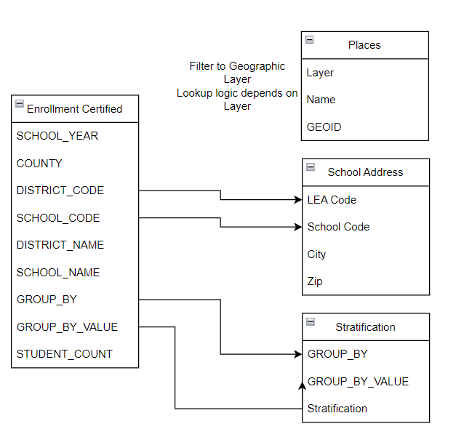

School Address File
WISEdash allows us to download the school directory file where we can get the zip code and city of the school to use for those aggregation layers. Do this lookup for every row in the Input File to add City and Zip.
Sd-export-public-schools-20241208.1059 (each year a new version needs to be downloaded)
If concatenating the two columns to make a key “string” to compare, be sure to remove leading zeroes from the fields being compared. Otherwise a match won’t be found.
Column | Column Heading | Comment
A | LEA Code | Join DISTRICT_CODE
C | School Code | Join SCHOOL_CODE
J | City | Set to “ERROR” if not found.
L | Zip | Set to “ERROR” if not found.

Stratifications File
Stratifications in Metopio each have a unique code. We need to translate the Group by fields and values into the ones we added there.
PP8 Stratifications.csv can be found in the FVDEX Teams Meeting Library. It may need to be updated if new values are found in new input files. PP8 and PP9 share the same stratifications.

Column | Column Heading | Comment
A | GROUP_BY | Join to GROUP_BY
B | GROUP_BY_VALUE | Join to GROUP_BY_VALUE
C | Stratification | Use this value in the output file

This file is manually created after adding the stratifications to the Metopio in the Administrator Site. Click on “Data” 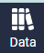 then “Stratifications” under “Topic Management”. Find the Metopio Stratification that will be used then click on its Name. Example:
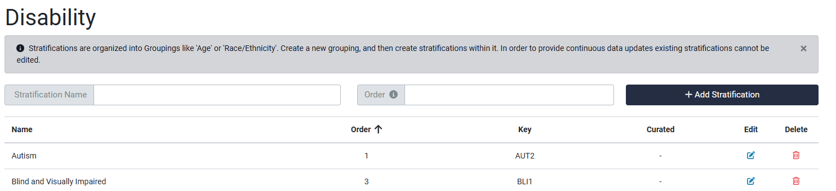
The “Key” is unique across all stratifications. This is what is needed in the Metopio upload file.

Places File
Fox Valley Data Exchange Places GEIODs.csv can be found in the FVDEX Teams Meeting Library. We use this file to obtain the GEOID used in Metopio for each place. This lookup is done differently for each aggregation layer below.
Column | Column Heading | Comment
A | Layer | Filter or join to the layer needed:  Region  County  Zip Code  City or town
B | Name | Join to this field using the input file
C | GEOID | Set to “ERROR” if not found.

This file was created manually by Metopio and sent to us. It can be recreated through the “Download” dropdown on the far left of the Atlas site, but this has to be done for each Geographic Layer and then combined. Since it doesn’t change, it is easier to simply use our saved file.

Output Files for Metopio

Format a .csv file with rows for each geographic layer. Steps:
1 – Read the above file and filter to these rows:

DISTRICT_NAME = [Statewide] or COUNTY = ‘Outagamie’, ‘Winnebago’, and ‘Calumet’
SCHOOL_NAME not=’Districtwide’
Group By not = ‘Migrant Status’
GRADE_LEVEL = 3
TEST_GROUP = ‘Forward’
TEST_RESULT = ‘Meeting’ or ’Advanced’
There are no redacted data points with this criteria.
This topic will show a % of the total student count

Statewide Layer

Filter to:
DISTRICT_NAME = [Statewide]
Column Name | Comment (granularity/sample values/aggregation method for measures)
layer | ‘State’
geoid | ‘WI’
topic | ‘FVDEHAAP’
stratification | See above notes
period | SCHOOL YEAR, but insert ‘20’ on the second year’s range (after the hyphen). So 2023-24 becomes 2023-2024
value | STUDENT_COUNT / STUDENT_COUNT for the “All Students” group.

Tri-County Layer

Filter to:
COUNTY = ‘Outagamie’, ‘Winnebago’, and ‘Calumet’

Column Name | Comment (granularity/sample values/aggregation method for measures)
layer | ‘Region’
geoid | ‘fox-valley’
topic | ‘FVDEHAAP’
stratification | See above notes
period | SCHOOL YEAR, but insert ‘20’ on the second year’s range. So 2023-24 becomes 2023-2024
value | REMOVAL_COUNT

County Layer

Filter to:
COUNTY = ‘Outagamie’, ‘Winnebago’, and ‘Calumet’

Column Name | Comment (granularity/sample values/aggregation method for measures)
layer | ‘County’
geoid | See notes above.  Filter Places source to Layer = ‘County’  Concatenate Input “COUNTY”, ‘ County, WI’ and match to Places.Name to get GEOID
topic | ‘FVDEHAAP’
stratification | See above notes
period | SCHOOL YEAR, but insert ‘20’ on the second year’s range. So 2023-24 becaomes 2023-2024
value | REMOVAL_COUNT

Zip Code Layer

Filter to:

COUNTY = ‘Outagamie’, ‘Winnebago’, and ‘Calumet’

Column Name | Comment (granularity/sample values/aggregation method for measures)
layer | ‘Zip Code’
geoid | Zip from School Address logic above
topic | ‘FVDEHAAP’
stratification | See above notes
period | SCHOOL YEAR, but insert ‘20’ on the second year’s range. So 2023-24 becaomes 2023-2024
value | REMOVAL_COUNT

City or town Layer

Filter to:

COUNTY = ‘Outagamie’, ‘Winnebago’, and ‘Calumet’

Column Name | Comment (granularity/sample values/aggregation method for measures)
layer | ‘City or town’
geoid | Filter the Place file to Layer = ‘City or town’.  Find the city for the school using the notes above to lookup School Address.  Concatenate to ‘, WI’  Match the concatenated SchoolAddress.City = Place.Name to get the GEOID  Set to “ERROR” if not found  3 towns are not included in the places file. Asked Metopio to add them.
topic | ‘FVDEHAAP’
stratification | See above notes
period | SCHOOL YEAR, but insert ‘20’ on the second year’s range. So 2023-24 becaomes 2023-2024
value | REMOVAL_COUNT

Validation Method
Step 1: For the most current year, manually mock up the expected Metopio load files using Excel pivot tables and vlookups to the lookup files.
Step 2: Compare the mock up to the output side by side with “true/false” comparisons on every column. “Pass” means that every cell matches.
Step 3: For additional years, we assume that the results will follow the norm, so we do not do mock-ups for those. Instead, we check for new stratifications and errors in the lookups.

Geo Layer | 2023 | 2022 | 2021 | 2020 | 2019 | 2018
State
Tri-County
County
Zip Code
City or Town

Step 4: Upload to Metopio to “unplublished” metric.
In the Administrator Tool, on the “Data” tab, under “Data Management”, click on “Upload Data”.
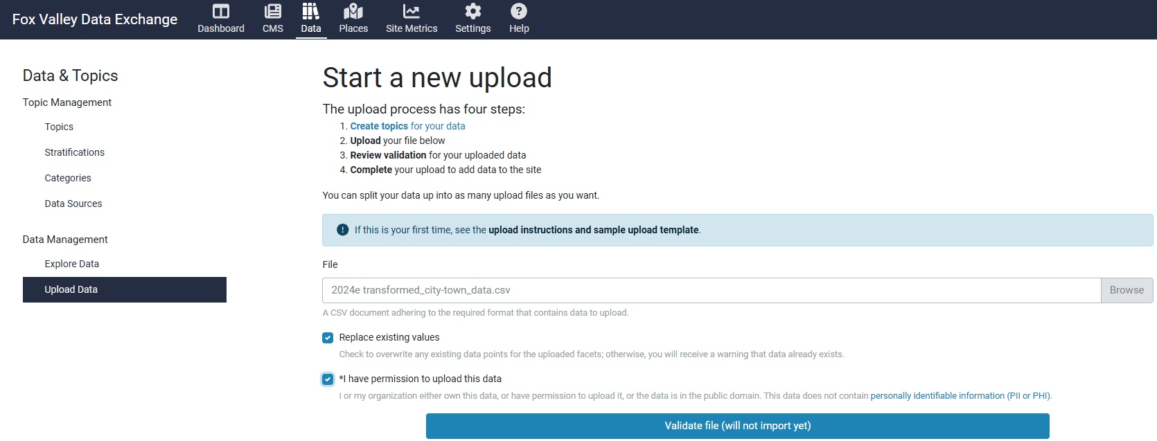
Click “Validate file (will not import yet)”
Scroll down on the list and click “Import Data” if there are no error messages:

Step 4: Spot Checks between Metopio and the source dashboard completed after loading the files.
If the Topic is not visible in the Atlas yet, we spot check from the Administrator tool. Click “Data” tab. Click “Explore Data” under “Data Management” (or Explore Data from the Topics entry). Spot check some of the values in the listed data.
Geo Layer | 2023 | 2022 | 2021 | 2020 | 2019 | 2018
State
Tri-County
County
Zip Code
City or Town

Step 5: March 2025 data load signed off by the FVDEX Executive Director on _______________________.
Step 6: Make data visible to public. In Administrator site, click “Data” tab and “Topics” under “Topic Management”. Edit and turn on Public View.
Step 7: Spot Check Metopio Dashboard to WISEDash. Check the map, chart, etc for new data added.
Step 8: Have requester review the topic
Step 9: Communicate the new topic to the Action Committee.

Code to format the files
This link has the Python code developed to format the Metopio upload files. Start with the “Readme” file.
https://github.com/shaazanaam/__wes_dataProcessor__.git

Authenticity

An "out-of-school suspension" (also known as "suspension") is a removal from school grounds imposed by the school administration for noncompliance with school district policies or rules; for threatening to destroy school property; or for endangering the property, health, or safety of those at school.
WISEdata is a multi-vendor, open data collection system that allows school districts, charter schools, and private schools participating in a parental Choice program to submit data to the Department of Public Instruction (DPI) from the student information system (SIS) vendor of their choice.

Comments

Hi Sarah Jean,

I’m working on loading the Disciplinary Action metric now. Unfortunately, this topic has three demographic layers and Metopio can only handle two. So we have some choices to make:

Proposed Name: # of Students Expelled or Suspended in

Here is a statewide example for gender:
Strat | Sub-Strat | Removal Type | Total Enrolled | Total Disciplined
Gender | Female | Expulsion with Services Offered | 398216 | 182
Gender | Female | Expulsion without Services Offered | 398216 | 127
Gender | Female | Out of School Suspension | 398216 | 28073
Gender | Male | Out of School Suspension | 424235 | 53976
Gender | Male | Expulsion without Services Offered | 424235 | 183
Gender | Male | Expulsion with Services Offered | 424235 | 288
Gender | Non-binary | Expulsion with Services Offered | 353 | 1
Gender | Non-binary | Out of School Suspension | 353 | 29
Gender | Unknown | Out of School Suspension | 0 | 14

Here are our options:
1 – Add the three removal types to one total by demographic group. Pro: see all demographics easily who were disciplined. Con: Don’t know detail disciplines, but people could go to WISEdash for more details if needed. This is the option I prefer, but will is it enough?

Public School K-12 Expelled or Suspended

Strat | Sub-Strat | Total Enrolled | Total Disciplined
Gender | Female | 398216 | 28382
Gender | Male | 424235 | 54447
Gender | Non-binary | 353 | 30
Gender | Unknown | 0 | 14

2 – Add each removal type as a separate topic by demographic group in addition to the total suggested above. Pro: see all demographics easily who were disciplined. Con: The individual removal types can’t be viewed together.

Public School K-12 Expelled or Suspended
Public School K-12 Expelled with Svc Offer
Public School K-12 Expelled without Svc Offer
Public School K-12 Out of School Suspension

3 – Combine the current Strat and Sub-Strat values into one that sits under the removal type:

Removal Type
Strat + Sub-Strat

Would look like this in stratifications:

